AZURE DEVOPS, AZURE BOARDS

Azure board is a tool in Azure Devops for managing and planning the work that needs to be done.

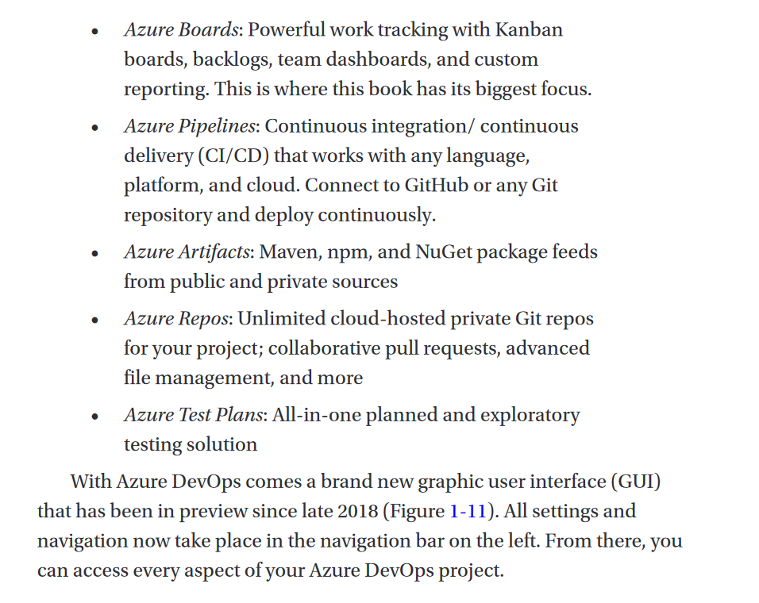

Project Settings

Project settings is a way of setting configurations for an azure devops project. It the place for configurating teams, managing notification and setting of iterations.

The Project settings button is at the left-bottom when you open any project. To make any changes to the project, click on it.

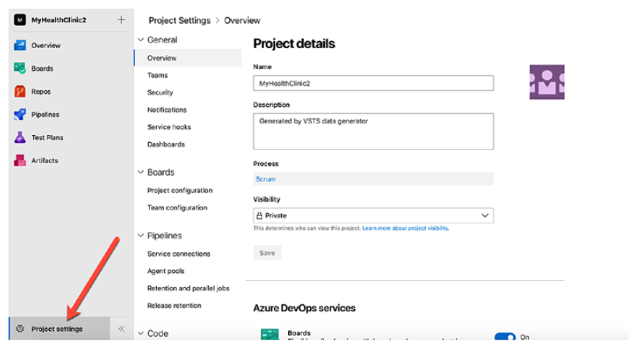

And if you are not going to be using all the devops features in your project. You can turn them off in your project settings…

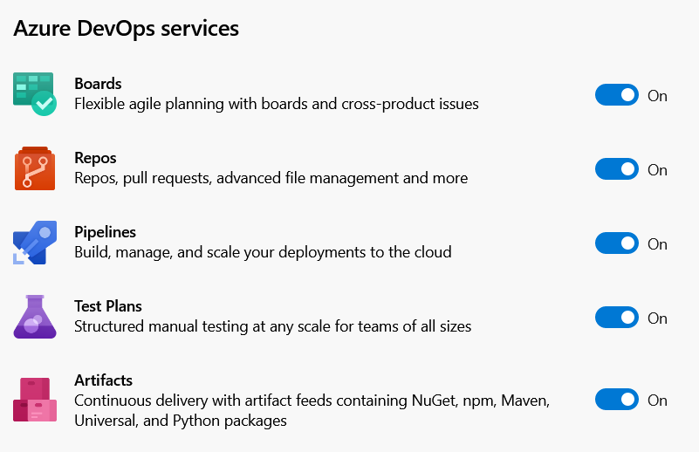

TERMS AND EXPLANATION

WORK ITEM 🡺 Is a piece/part of work that needs to be completed in the project. For example, if you are developing delivery app, that’s the project. And you may decide to create the homepage, and the about page tomorrow. That’s the work-items that needs to be done for tomorrow.